
COMSATS UNIVERSITY ISLAMABAD, ATTOCK CAMPUS

COMPUTER SCIENCE DEPARTMENT
BSSE-4

Course Title: Statistics And Probability

SUBMITTED BY: ZAINAB KHAN
REGISTRATION NUMBER:FA22-BSE-032

SUBMITTED TO: DR. SHAHID HUSSAIN
ASSIGNMENT NUMBER: 01
DATE OF SUBMISSION: 4TH MARCH,2024

DESCRIPTION OF A DATA SET:

The data set hold the data related to the Impact Of Income On Life in the South Africa, Botswana and Namibia from the year 1996 to 2015 the data includes various indicators such as GDP per capita, healthcare expenditure, income, mortality rates, life expectancy.
- Quantitative Variables:
The quantitative data includes the numerical values as: GDP per capita ,mortality rate and education rate of these 3 countries.

- Qualitative Variables:
The qualitative data includes the country and the year.

The link used is: data.mendly.com
DISTRIBUTIVE FREQUENCY FOR QUALITATIVE VARIABLES: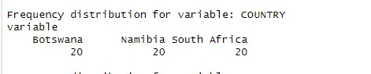
FREQUENCY DISTRIBUTION OF VARIABLE YEAR:
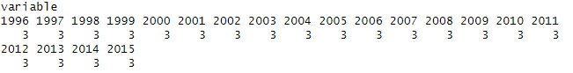

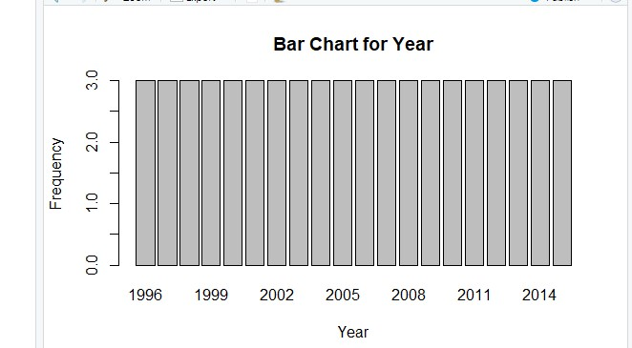
BAR GRAPHS AND PIE-CHARTS FOR QUALITATIVE VARIABLES:
The bar graph for Year shows the frequency distribution of different years present in the dataset. Each bar represents a year, and the height of the bar indicates the frequency or count of occurrences of data entries corresponding to that year in the dataset.

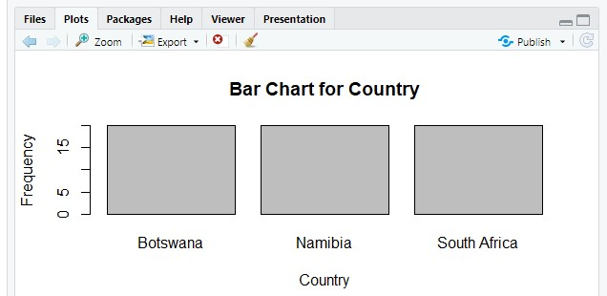
The bar graph for Country shows the frequency distribution of different countries present in the dataset. Each bar represents a country, and the height of the bar indicates the frequency or count of occurrences of that country in the dataset.
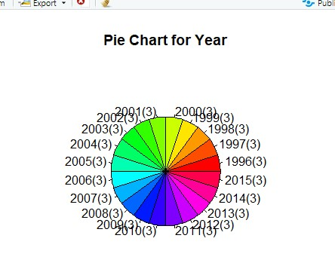
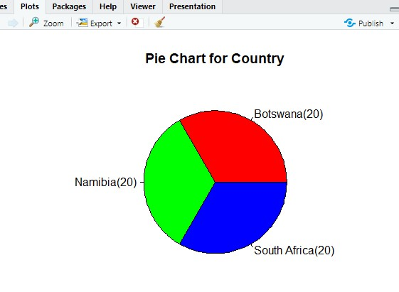

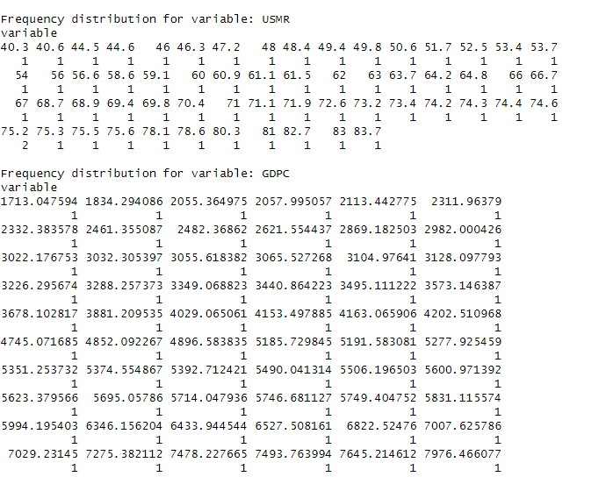
DISTRIBUTIVE FREQUENCY FOR QUATITATIVE VARIABLES:
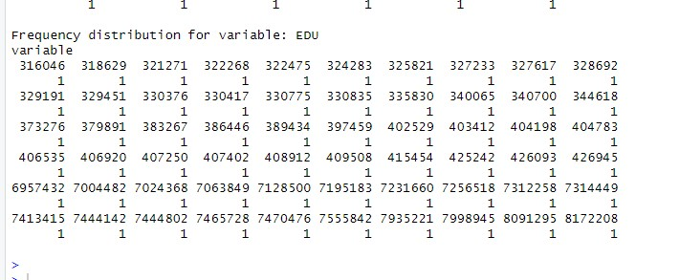
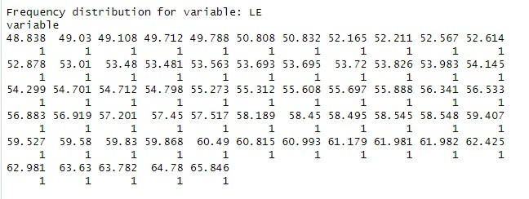
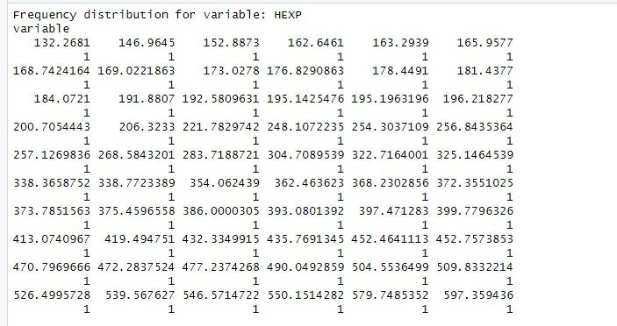

HISTOGRAM AND LINE GRAPHS FOR QUANTITATIVE VARIABLE:
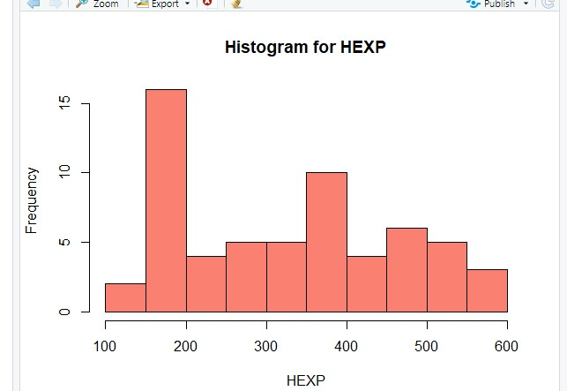
This histogram shows the distribution of Health Expenditure (HEXP) values. It gives an overview of how HEXP values are distributed across different levels of expenditure.

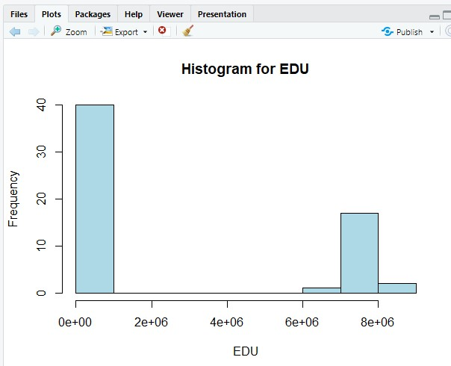

This histogram shows the distribution of Education (EDU) values. It provides insight into the spread of EDU values across different levels of education.
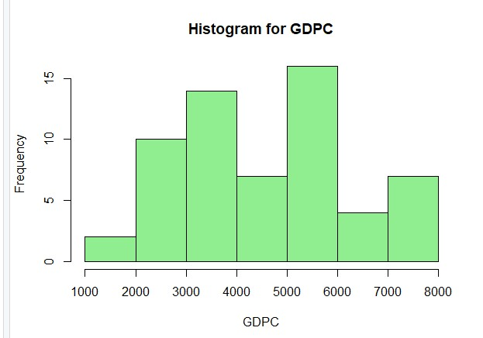
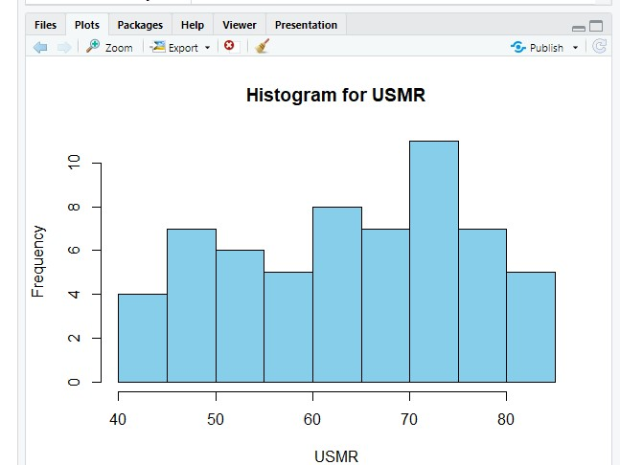
This histogram shows the distribution of Gross Domestic Product per Capita (GDPC) values. It provides information about the spread of GDPC values across different ranges.

This histogram shows the distribution of Under-5 Mortality Rate (USMR) values. It gives insight into how the USMR values are spread across different ranges.
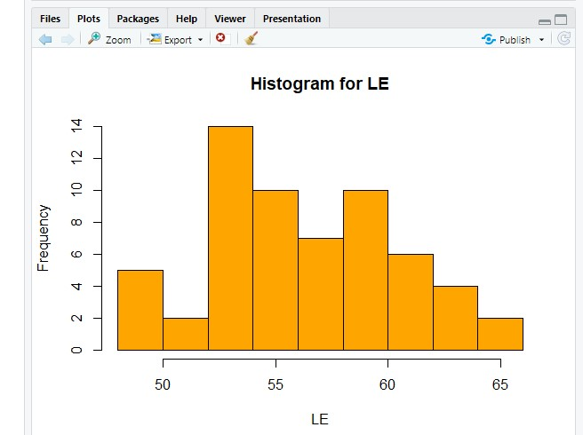
This histogram shows the distribution of Life Expectancy (LE) values. It gives an overview of how LE values are spread across different age ranges.

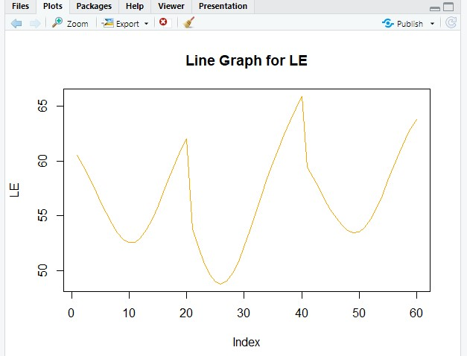
LINE GRAPHS:

This chart illustrates the trend of Life Expectancy (LE) over time or across different observations. It allows you to visualize changes in life expectancy and assess improvements or declines in population health and longevity over the specified period.
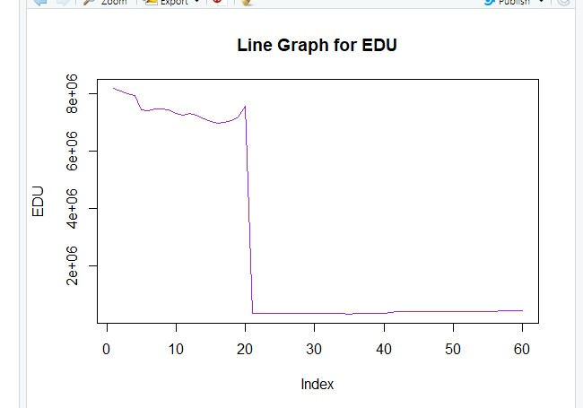

This chart demonstrates the trend of Education (EDU) values over time or across different observations. It provides insight into changes in educational attainment or investment in education over the period covered by the dataset.

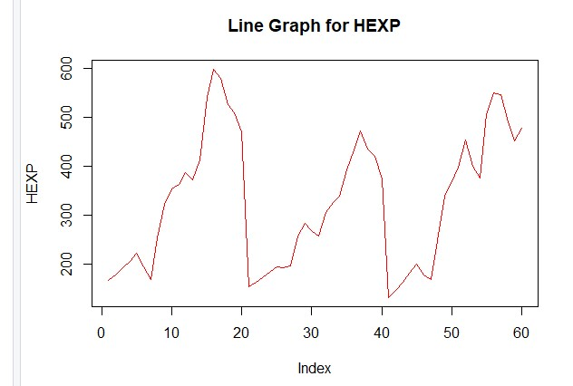
This chart displays the trend of Health Expenditure (HEXP) over time or across different observations. It allows you to visualize the patterns of healthcare spending and assess changes in healthcare investment over the specified period.
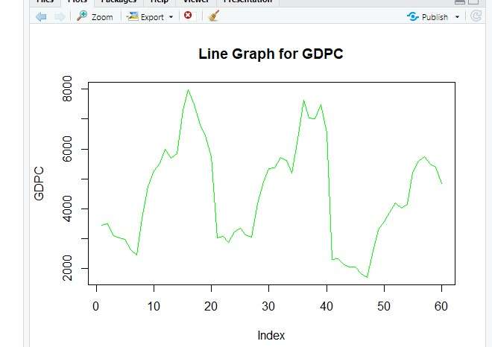
This chart illustrates the trend of Gross Domestic Product per Capita (GDPC) over time or across different observations. It provides insight into the changes in GDPC values and economic growth trends.

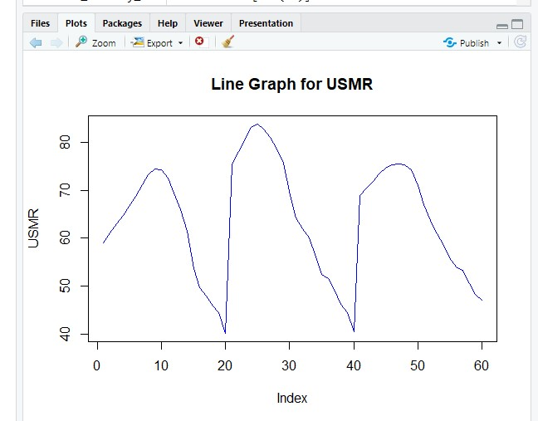
This chart shows the trend of Under-5 Mortality Rate (USMR) over time or across different observations. It allows you to visualize how the USMR values have changed over the period covered by the dataset.

